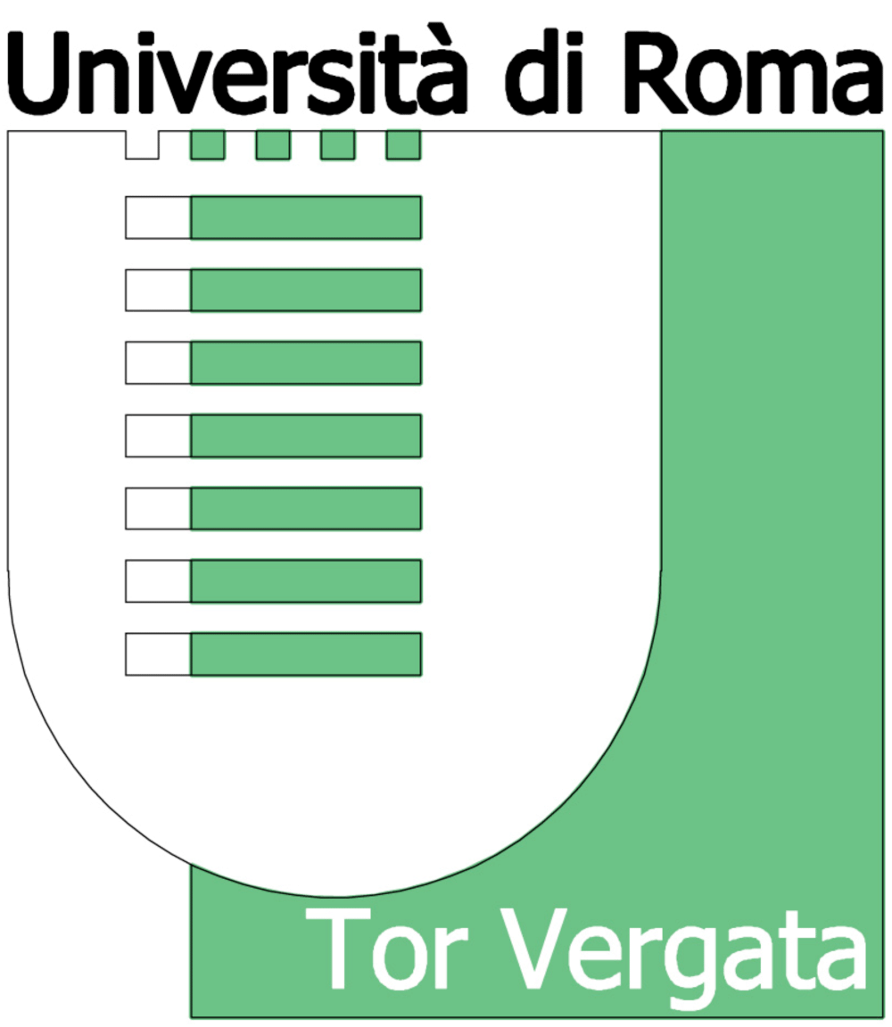

UNIVERSITA` DEGLI STUDI DI ROMA TOR VERGATA
Dipartimento di Biologia

Master of Science in Biotechnology
Program Handbook 2016-17
1.0 - June 2016

TABLE OF CONTENTS
Program Goals 3
Degree Requirements 3
Core Courses 4
Elective Courses 4
COURSES SCHEDULE 2016-2017 5
HOW to calculate the graduation mark 6
Admission Requirements 7
Admission procedure 7
Tuition Fees 8
Housing 8
Further Benefits 8
Program Contact Information 9
Directions 9
DESCRIPTION OF core COURSES 10

PROGRAM GOALS

Through this program, students will be able to develop a deep knowledge of the theory and fundamentals of biotechnology and develop biotechnology laboratory skills, with a comprehension of the real-world biotech business.
Graduates will acquire the competence needed to work in the field of:
- Research in gene manipulation and production of proteins
- Creation and monitoring of genetically modified organisms
- Pharmacology
- Food industry and food control
- Industrial and environmental quality control
- Molecular diagnostics
- Teaching (in Italy, class 60/A – high schools)
They also get access to Ph.D. programs and to other secondary specialization schools.

Degree Requirements
To complete the program, a total of 120 credits (CFU) must be acquired. 1 CFU is conventionally set as corresponding to 8 hours of lessons plus 16 hours of personal study, or to 12 hours of laboratory experience.
Of the 120 CFU, 77 credits are from Core Courses and 9 credits are from Elective Courses. The final 34 CFU must be acquired by the students performing experimental lab work (usually in a 6-8 months internship project yielding publication-quality research), writing a 50-80 pages dissertation on its results and defending the dissertation.

Core Courses (with the number of CFU and the relative scientific discipline (SSD) according to Italian regulations). Some courses are administered in two modules.

Course | CFU | SSD
Applied Ecology | 6 | BIO/07
Applied Economics | 6 | SECS-P/06
Applied Immunology | 6 | MED/04
Biosensor Technology | 6 | CHIM/01
Gene expression and regulation | 6 | BIO/18
Microbial Technology | 6 | BIO/19
Nanobiotechnology | 6 | BIO/13
Pharmaceutical applications of plant metabolites | 6 | BIO/04
Pharmacology and Pharmaceutical Chemistry | 12 | BIO/14  CHIM/08
Plant Biomass and Phytotechnologies | 6 | BIO/01
Structural and Industrial Biochemistry | 11 | BIO/10  BIO/11

The description of core courses can be found at page 10.

Elective Courses
Students must attend Elective Courses to totalize 9 CFU (or more), choosing among those listed below.
As Elective Courses students can also choose to attend any course offered by the MacroArea of Science, University of Tor Vergata (subject to previous approval of the Coordinator of the degree courses in Biotechnology).
For the year 2016-17 the following Elective Courses are proposed:

Course | CFU
Applying to European Union Calls | 4
Plant micropropagation | 4
High-Throughput technologies in drug discovery | 2
European pharmaceutical legislation | 5
Food Chemistry | 5
Modern techniques of protein identification and Molecular Recognition Methods | 3
Methods for genetic modification of bacteria: application in basic and applied research | 2
Genes and Nutrition | 2

The description of elective courses can be found on the webpage http://www.biotechuniroma2.it/courses/.

COURSES SCHEDULE 2016-2017
Lessons will start at the very beginning of October 2015. The detailed Lessons Schedule will be available online in September 2016. Attending at least 70 % of lessons is mandatory.
Courses will be organized as follows:

FIRST YEAR
 | CFU | SSD
FIRST SEMESTER (beginning in the first week of October)
Plant Biomass and Phytotechnologies | 6 | BIO/01
Applied Ecology | 6 | BIO/07
Pharmacology and Pharmaceutical Chemistry (2 modules) | 6+6 | BIO/14, CHIM/08
Structural and Industrial Biochemistry | 8+3 | BIO/10, BIO/11
SECOND SEMESTER (beginning in the first week of March)
Applied Immunology | 6 | MED/04
Biosensor Technology | 6 | CHIM/01
Pharmaceutical applications of plant metabolites | 6 | BIO/04
Gene expression and regulation | 6 | BIO/18
Microbial Technology | 6 | BIO/19
TOTAL CFU, 1st Year | 65
SECOND YEAR
 | CFU | SSD
FIRST SEMESTER (beginning in the first week of October)
Nanobiotechnology | 6 | BIO/13
Applied Economics | 6 | SECS-P/06
Elective courses | 9
Internship and Dissertation | 34
TOTAL CFU, 2nd Year | 55
TOTAL CFU | 120

Criteria to calculate the final graduation mark

The final mark may vary from 66/110 (pass) to 110/110 cum laude (outstanding).

It will be assigned adding the following:

1. Starting vote: average of marks from exams, expressed on 110 (e.g. 27/30 = 99/110)

2. points awarded to the final report and thesis defense by the Commission
(7 members + President) 0-8 points

3. bonus:
a. number of years to obtain the degree: graduation in the
• 1st session, July (end of the second year) 3 points
• 2nd session, October (end of the second year) 1 point
• any other later session 0 points

b. Erasmus or other stage in a foreign country (max 3 points)
calculated according to the following criteria:
b1. Passing exams abroad 1-3 points
6-11 CFU: 1 point
12-17 CFU: 2 points
> 18 CFU: 3 points
b2. Laboratory training abroad 3 points

c. For each exam passed with honors, excluding elective courses: 0.2 points

The notation “with honors” (cum laude) may be given unanimously by the Commission to students
who have achieved a final score of at least 112/110.

Admission Requirements
A maximum of 60 students will be admitted.
Citizens from Italy, other EU countries and non-EU countries are equally admitted to the selection.
All students must request preliminary assessment of their previous studies (see below). Non-EU candidates not residing in Italy must proceed first with the assessment of their previous studies and then with the pre-enrollment procedure at the Italian Embassy or Consulate in their country, before the opening of the online application.

For admission into the M.Sc. in Biotechnology, the prospective student must have:
- Sufficient background in the following:
Mathematics, Chemistry and Physics;
Biochemistry, Cell Biology, Molecular Biology, Genetics, Animal and Plant Physiology, Microbiology, Virology, Statistics, Basic economy and Bioethics
Therefore, they should have a Bachelor’s degree in Biology or Biotechnology. Admission of students possessing other university first level degrees is possible upon preliminary assessment of their previous academic career by an ad hoc Committee. Admission is allowed by the Committee if the number of CFU not already possessed by the student is less than 35. If a formative debt is assigned by the Committee, prospective student must fulfill the requirement prior to enrollment.
- A Bachelor’s degree from an accredited institution with a minimum grade point average (GPA) of 3.0 or B+ or 70 % depending on the system (95/110 for Italian students). Students with a lower GPA may submit a request of special evaluation of their application. Official Transcripts of all post-secondary colleges or universities attended are needed.
- A B2 Common European Framework (CEF) or Test of English as a Foreign Language (TOEFL IBT > 80; TOEFL PBT > 550) or an IELTS > 6.0 certificate of English. Alternatively, they must demonstrate a sufficient knowledge of spoken and written English during a test administered via Skype.
- Two letters of recommendation (foreign students only).

Admission procedure

Italian students: Preliminary assessment of requisites must be requested via the online procedure at http://delphi.uniroma2.it > Richiesta verifica requisiti curriculari.
General information (Guida dello studente) can be found at
http://web.uniroma2.it/modules.php?name=Content&navpath=STD&section_parent=442
If a certificate of English is not available, students must contact the Coordinator of the Degree, Prof. Maria Teresa Carrì via email carri@Bio.uniroma2.it, in order to set a date for the English test.

Foreign students: Detailed instructions for enrollment can be found on the website
http://internationalstudents.uniroma2.it/
Preliminary assessment of requisites must be requested via online procedure at http://delphi.uniroma2.it/totem/jsp/homeStudenti.jsp?language=EN > Assessment
where students can register and upload their certificates.
If a certificate of English is not available, students must contact the Coordinator of the Degree, Prof. Maria Teresa Carrì via email carri@Bio.uniroma2.it, in order to set a date for the English test administered via Skype.

Enrollment usually takes place between September and November of each year. In the academic year 2016/2017 the Call will be out in July 2016 but Foreign Students are invited to Pre-enroll in March-June 2016.
For information on preliminary procedures Foreign students may refer to the
Ufficio studenti stranieri – Via Orazio Raimondo,18 – 00173 ROMA
(email: studenti.stranieri@uniroma2.it)
Office Hours:
Mondays: from 9,00 a.m. to 12,00 a.m.
Wednesdays: from 9,00 a.m. to 12,00 a.m. - 14,00 p.m. to 16,00 p.m.
and Fridays from 9,00 a.m. to 12,00 a.m.

Enrollment application forms must be completed on-line at http://delphi.uniroma2.it and then handed in to the Students’ Secretary.

Tuition Fees
Annual tuition fee is € 1000 plus regular University fees, which depend on family income (range is min € 16 – max € 1933 for 2016-17). Fees do not cover the costs of living and study materials.
The Fee for each Academic Year must be paid in three installments. Late enrollment is subjected to penalty fees.
Students applying for a Laziodisu fellowship will pay € 16 only in the first installment (Enrollment);
winners of the Laziodisu fellowship will be exempted from fees.
Late enrolment is subjected to penalty fees.
Please refer to the Students Office for up-to-date information about tuition and fees.

Italian students not resident in Rome may apply for a LAZIODISU scholarship. Information can be found at
http://www.laziodisu.it/bando/

Non-Italian Students may apply for a LAZIODISU scholarship (as above) and for other fellowships, to be found at
http://internationalstudents.uniroma2.it/ - Section Services

Housing
Students can apply for a room in the University Residence Campus X.
The University of Rome Tor Vergata has a University Residence inside the Campus, where Italian and International students can live. The residence provides flats with single rooms where students share a kitchen and toilet. Campus X is a residential structure to be enjoyed, with green areas, study halls, sports facilities, minimarket, canteen, gym and spa.
For further information you can visit:
http://internationalstudents.uniroma2.it/ - Section Services
or
http://www.campusx.it/cxroma/international/

Further Benefits
The University of Tor Vergata offers to students the possibility to benefit from a number of discounts in shops, restaurants, gyms and others. Offers can be found at
http://agevola.uniroma2.it/

Program Contact Information

Coordinator of the Degree: Prof. Maria Teresa Carrì email carri@Bio.uniroma2.it
Vice-coordinator of the Degree: Prof. Patrizia Malaspina email malaspin@uniroma2.it

Directions
The Department of Biology is located in Via della Ricerca Scientifica 1 (Roma - 00133), outside the ring road "GRA - Grande Raccordo Anulare", in the Building of the Facoltà di Scienze MM.FF.NN (now called MacroArea di Scienze).

By public transportation
Metro + Bus: take the subway line A and get off at the end of the line ("Anagnina" station), take the bus 500 or 046 and get off at the stop “Facoltà di Scienze”.

By car
Take the "GRA - Grande Raccordo Anulare", exit to "La Romanina" (exit 19-20), follow the signs to "Tor Vergata - Facoltà di Science MM.FF.NN".

DESCRIPTION OF CORE COURSES

Applied Ecology
Aims: The course aims at giving the cultural background and methodology to understand the environmental effects at various levels resulting from the application of technology and management processes, and deal with them with a view to the principles of ecology and sustainability.
Program: Ecological principles for the sustainable management of natural resources (natural dynamics, anthropogenic pressures, environmental issues and sustainable development).
The key points of ecosystem functioning and of the compartments of the environment (air, water, soil), for the assessment of the effects of human actions at different space and time scales. Environmental issues (over-exploitation of natural resources, extinction of wild fauna and flora, habitat loss, pollution): causes, dynamics, consequences at the local and the global level.
Measure of the environmental components: ecological modeling, information systems, bio-monitoring.
Legislative frameworks, elements for the assessment of environmental risk.
Introduction to ecological economics and environmental ethics.

Applied Economics
Aims: The aim of the course is twofold. The aim of the first part, concerning sustainable development, is to develop the economic framework concerning the use of natural resources in a sustainable way. Special attention is dedicated to the economic analysis of the renewable resources. The second part concerns the evaluation projects. Special attention is devote to the cost and benefit analysis and to the R&D projects. The third part concerns sanitary economics.
Program: Part I: Sustainable development; sources of energy; Demand of energy; Renewable energy: the European approach; Energy market in Italy; Hydro energy; Geothermal energy; Wind energy; Solar energy;
Biomass; Smart cities
Part II: Biotec in Italy; the evaluation of investment projects; cost-benefit analysis; the theory of real options. Research and Development: definition, problems and prospects; Methods of financing R&D.
Part III: Sanitary economics

Applied Immunology
Aims: The aim of the course is to provide the scientific and technological knowledge in the field of immunological diagnostics, vaccines and immunotherapy.
Program: Cellular and molecular components of the innate and adaptive immune response.
Immunopathology. Immune response in infectious diseases.
Poverty-related diseases and neglected infectious diseases.
Monoclonal antibodies: production and use in research, diagnosis and therapy.
Isolation of peripheral blood mononuclear cells and purification of lymphocytes subsets.
Characterization of T and B lymphocytes. Characterization of antibodies and their use in research and diagnosis.
Development strategies of diagnostic tools for infectious diseases.
Immunotherapeutic strategies in chronic inflammation diseases, autoimmunity, transplant rejection and cancer.
Vaccines: recombinant vaccines, DNA vaccines, live attenuated vaccines.
Adjuvancy: microbial and natural adjuvants. Vaccine delivery
Reverse vaccinology. Identification of T and B epitopes: phage libraries and bioinformatic prediction. Characterization of the effectiveness and safety of vaccines

Biosensor Technology
Aims: Knowledege of equilibria in solution. Ability to select and use biosensors
Program: Acid-base equilibria, Precipitation equilibria, complex and redox equilibria
Ion selective electrodes. Amperometric and potentiometric chemical sensors. Biosensors, immunosensors, DNA sensors. Electrochemical, optical, calorimetric, piezoelectric biosensors.
Applications in food, clinical and environmental areas with focus on industry

Gene expression and regulation
Aims: Advanced knowledge on molecular mechanisms that ensure gene expression regulation and are involved in cellular homeostasis and cancer. Applications of technologies to study gene expression, using the identification of novel therapeutic targets in cancer as a model system.
The students will learn to develop and discuss a project related to the evaluation of gene expression regulation.
Program: References and insights on molecular mechanism that ensure the control of gene expression: epigenetic control, transcriptional and post-transcriptional control. Role of microRNAs. Translational and post-translational control.
Post-translational modifications and signal transduction: positive and negative feedback loop, redundancy and robustness.
Examples of technical strategies employed to study gene expression.
Examples of gene expression regulation.
Cancer as an example of gene expression deregulation: tumorigenesis, oncogenes and tumor suppressors, mutations. Analysis of signal transduction pathways to define novel therapeutic targets in cancer.

Microbial Technology
Aims: A deep insight on the microbe/man interaction dynamics, the importance of the human associated microbiota and its possible outcomes. Students should understand the bacterial virulence strategies and the current state and perspectives of fighting them. They should acquire the basic skills to handle the main microorganisms used for microbial biotechnologies.
Program: Microbe/man interactions and their possible outcomes. Bacterial pathogens: pathogenic power and virulence. Virulence evolution, strategies and mechanisms. The Human-associated microbiota: community structure and diversity. Influence of age, diet and genetic background on the microbiota/host interactions; possible outcomes of microbiome expression and microbiota alterations. Fighting pathogens: antibiotics, bacterial resistance strategies and related problems. Facing “superbugs” with the phage therapy. Microorganisms and biotechnology: basics, history, research fields. Choosing the optimal host Codon, adaptation index and PLS modeling. Industrial employing of microorganisms. Microbes for biotechnologies: taxonomy, features, cultivation, genetic manipulation and heterologous expression in Bacteria (Escherichia coli; Bacillus, Lactic Acid bacilli –LABs-and Streptomyces) and -Yeasts (Saccharomyces, Hansenula, Pichia, Kluyveromyces)

Nanobiotechnology
Aims: to provide the scientific and technological bases of the application of nanotechnology to the biomedical field.
Program: Nanotechnology: terminology; materials science and engineering; properties of nanostrutured materials; size, shape, zeta potential, surface, aggregation, colloidal stability, functionalization, solubilty, ion release.
- Pharmacological exploitation of the intrinsic features of nanoparticles
- Interactions between nanoparticles and living matter: spontaneous functionalization and protein corona; biokinetics: routes of entry and excretion.
- Paradigms of nanotoxicology; nanoparticles relevant for human exposure; nanoparticulate pollution and occupational exposure; safety issues.
- Principles of nanomedicine: paradigms, expectations and perspectives; polyfunctional platforms; targeting; biocompatibility; smart materials.
- Drug delivery: capsules, micelles, polymers; differential release.
- Tissue engineering: generalities; scaffold; 3D cultures; stem cells;
- Nanobioinformatics: bioinformatics applied to biological function of nanoparticles and nanotoxicology.

Pharmaceutical applications of plant metabolites
Aims: Knowledge of biochemistry of plant bioactive metabolites and of their properties and applications
Program: Distribution and characterization of bioactive natural products in plants.
Role of secondary metabolites in plant defense against pathogens and herbivores.
Biosynthesis of phenolic compounds.
Biosynthesis of terpenes , from mono to tetraterpenes.
Nitrogen-containing compounds. Alkaloids, cyanogenic glucosides, glucosinolates.
Plants containing metabolites of each group will be described as well as their applications in pharmacology and nutrition.
Laboratory : drugs, balsamic time, extracts, bud extract, tincture, essential oils.
Methods for separation and identification of natural substances.

Pharmacology and Pharmaceutical Chemistry
Pharmacology
Aims: The objectives of the course are to identify major drug classes, discriminate among major drug classes by their mechanism of action at the molecular, cellular and organism levels and describe the basis for drug action on specific cells, tissues, organs as a basis for decisions regarding application in human therapeutics
Program: Pharmacokinetics: the dynamic of drug absorption, distribution, metabolism and elimination. Routes of administration. Pharmacodynamics: Definition of drug. Drug-receptor interaction (pD2). Agonists, antagonists (pA2), inverse agonists. Potency and efficacy. Therapeutic index. Families of receptors and signaling pathways. Ion channels, G-protein-coupled receptor, receptor protein kinases, intracellular receptors. Transcription factors. Agonist and antagonist ligands. Regulation of receptors.
Drugs acting on the Peripheral Autonomic System. Drugs acting on the Central nervous system. Drugs affecting tissue responses. Drugs affecting gastrointestinal function. Drugs affecting respiratory function. Drugs affecting cardiovascular function. Drugs affecting renal function. Drugs affecting the endocrine system. Principles of chemotherapy.
Pharmaceutical Chemistry
Aims: This is a foundation course whose aims are to provide an introduction to the principles of Medicinal chemistry, including an understanding of drug structure-activity relationships, prediction of the physico-chemical properties of a drug, basic knowledge of the major pathways of drug metabolism, and factors that can contribute to drug-drug interactions. Students will be also shown how to predict the structure-activity relationships, basic synthesis routes for selected structures, metabolism and pharmacological activity/potency/safety of drug classes and individual members of classes based on the contribution of their functional groups to their structures. In particular H1 and H2 antagonists, cholinergic and adrenergic drugs as well as antineoplastic agents.
Program:
1- Target Class
2- Molecular Interaction and Drug Potency
3- Drug Metabolism
4- Physical Properties
5- Finding a Lead
6- Drug Design
7- Safety Assessment
8- NOSynthase Inhibitor
9- Cholinergics
10- Adrenergics
11- Antihistamines
12- Oncological chemotherapy

Plant Biomass and Phytotechnologies
Aims: The aims of the course are to foster a fast paced immersion into some aspects of plant biotechnologies. Students will merge their interdisciplinary knowledge with the learning about phytotechnologies and on how to recognize, understand and find solutions to some of the global problems related to feed, fuel and ecosystem management in an environmentally friendly and sustainable manner.
Program: Plant biomass production and methods of yield evaluation. Biomass utilization for energy production. Woody biomass. First and second generation biofuels. Biomass, carbon sequestration and climate change.
Tools of plant biotechnology to enhance sustainable and profitable agricultural production systems.
Plant cell and tissue cultures. Micropropagation. Somatic embryos. Somaclonal variation. Control mechanisms of plant cell fate. Chromatin remodelling in plant development.
Plant cells cultures as a tool for the production of useful compounds. From lab bench to industrial scale. Bioreactors. Protoplasts and somatic hybrids.
Germplasm preservation. Methods of ex situ germplasm preservation.
Production of biopharmaceuticals, bioplastics. Molecular pharming and transgenic plants. Phytotechnologies and environment.

Structural and Industrial Biochemistry
Industrial Biochemistry
Aims: The course aims at highlighting some of the main applications of biochemistry in the industrial, medical and food preparation fields.
Program: Fermentations and their applications. Biotechnologies and biofuel production. Analysis of the different applications of protein in the pharmaceutical field, in food industry, in analytical chemistry, in agriculture and animal husbandry and in other applicative areas. Procedures for the production and isolation of proteins of biotechnological interest. Discussion of issues concerning the relationships between protein structure and function. Modification of enzymes and proteins aimed to their improved use in the industrial and pharmaceutical fields. Immobilized enzymes. Biosensors.
Structural Biochemistry
Aims: At the end of the course the student must know the non covalent interactions that permit a protein to reach its 3-dimensional structure, its stability and the principles of macromolecular recognition. The student must also know the structure and the function of some specific enzyme.
Program: Properties of the non covalent interactions. Quantitative evaluation of the non covalent interaction contributions to the protein stability. folding, unfolding and misfolding processes. The main structural motifs. Examples of molecular recognition : Protein-DNA interaction, Antigene-Antibody interaction, Enzyme-substrate interactions. Structural and functional properties of transport membrane proteins.

